Volume ##, Issue ##
Month Date, 2017

Vectorborne Disease Monitoring Report

West Nile Virus Surveillance Summary

(Insert date of report data; typically week off release)

- Insert State/Large jurisdiction surveillance numbers here (number and types of human cases)

- Insert local jurisdiction surveillance numbers here (number and types of human cases, blood donors who tested positive, etc).

Zika Virus Surveillance Summary

(As of MM/DD/YY)
- Locally acquired zika overview. Example: There has been zero locally acquired Zika cases in Oklahoma State and Oklahoma County.

- State/large jurisdiction Zika surveillance updates: number of travel related cases investigated, pregnant women, etc.

- Local jurisdiction Zika surveillance updates: number of travel related cases investigated in local jurisdiction, etc.

- Data trends, for example, all of the travel cases were associated with travel to Country A

- Zika Virus testing is coordinated through Oklahoma State Department of Health and the patient’s physician.

Local Mosquito Surveillance (As of MM/DD/YY)

- Mosquito Collection and Testing

Date | Total Mosquitos  Collected | Total Mosquitos  Tested (%) | Total Traps Sites  Positive for WNV*
5/25/2016 | 533 | ##(##.#) | #
6/1/2016 | ## | ##(##.#) | #
6/8/2016 | ## | ##(##.#) | #
6/15/2016 | ## | ##(##.#) | #
6/22/2016 | ## | ##(##.#) | #
6/29/2016 | ## | ##(##.#) | #
7/6/2016 | ## | ##(##.#) | #
7/13/2016 | ## | ##(##.#) | #
7/20/2016 | ## | ##(##.#) | #
7/27/2016 | ## | ##(##.#) | #
8/3/2016 | ## | ##(##.#) | #
8/10/2016 | ## | ##(##.#) | #
8/17/2016 | ## | ##(##.#) | #
8/24/2016 | ## | ##(##.#) | #
8/31/2016 | ## | ##(##.#) | #
Grand Total | SUM OF Column | SUM OF Column | SUM of Column
*Minimum of 5 female mosquitos required for test

- Update on vector surveillance. For example: Number of mosquitos known to transmit Zika have been collected or differentiate types of species

- Insert Larvicide and Complaints Data here (as of MM/DD/YY), some examples include
Water bodies treated | ##
Total estimated gallons treated | ##
Number of complaints addressed since MM/DD/YY (start of season) | ##

National West Nile Virus Surveillance Summary
- This data is pulled from the Centers for Disease Control and Prevention, and can include items such as:
- West Nile Virus activity has been recorded in 47 states and the District of Columbia as of MM/DD/YY (see map below map from CDC).

- #### human cases have been identified in the United States by the Centers for Disease Control and Prevention (CDC), of these ### (##%) were neuroinvasive and ### (##%) were non-neuroinvasive.

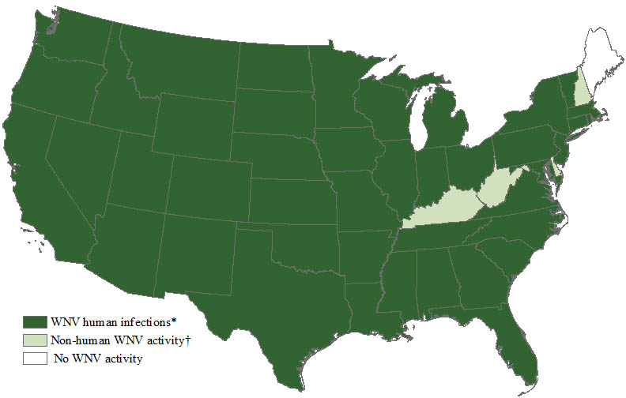

National Zika Virus Surveillance Summary
- This data is pulled from the Centers for Disease Control and Prevention, and can include items such as:
- ###total cases have been identified in the United States by the Centers for Disease Control and Prevention (as of MM/DD/YY).
  - ## cases were sexually transmitted
  - ## cases had Guillain-Barré syndrome
  - #### cases are travel-associated cases
  - # is a laboratory acquired case
  - ### are locally acquired cases, all in Southern Florida (see map below, map from CDC).
